`

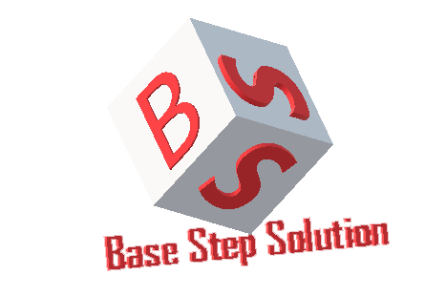

Meeting Minutes

Van Lang Admissions

# Revision Table

|  |  |  |  |
| --- | --- | --- | --- |
| **Author** | **Date** | **Reason for changes** | **Version** |
| Khoi Nguyen | 23/02/2017 | Initial Document | 1.0 |

Table of Contents

Revision Table 1

I. Purpose 3

II. Participant in meeting 3

III. Content of meeting 3

IV. To do task 5

|  |  |  |  |  |  |
| --- | --- | --- | --- | --- | --- |
| **Writer:** | Khởi Nguyễn | **Location:** | Floor 9 Etown 2 | | |
| **Date:** | 23/02/2017 | **Start:** | 19h | **Finish:** | 20h30 |

# Purpose

* Prepare for EOMP 2

# participant in meeting

Mentor Vũ Thế Nam

Team Capston:

* Nguyễn Thái Hiền
* Nguyễn Hoàng Anh Tài
* Đoàn Anh Minh
* Trần Xuân Hải
* Nguyễn Anh Khởi

# Content of meeting

* Angular devide into backend-frontend to meet security : Multiple layers
* Cache & index server to meet
* Present slide
  + Topic name & group name
  + Slide content
  + Progress report
  + Content of EOMP
  + My status / my difficulty / we have delay? / What is the delay? why ? Solution ?
  + reflection : Come from the happen badthing in risk : can map with risk
* *** must have sheet timelog : number total of each member ***
* Notice two things budget & number task/feature
* Difference between BCWA - BCWP - ACWP
* Preparing excel statistics figures
* Where Risk list ? risk report?
* Probability : use scale or ranking or score
* How to calculate probability: voting members: take averages
* Risk occurred: what date?Lack of risk list from the beginning
* Redis : connect 2 machines together - not connected to mongodb
* Function search : demo auto update
* layout : nanyang
* Change languages : have file dictionary .
* News : Must have attribute is language
* Manual test

# To do task

* Update document
* Prepare for EOMP 2

---- *** ----